Structure of a B+ Tree
A B+ Tree is a balanced, multi-way search tree.
Unlike binary trees, where each node has at most two children, a B+ Tree node can have many children. This reduces the tree height and makes searches faster.
Important Properties
1. Perfect Balance
Every path from the root to a leaf node has the same length. No brach is deeper than another.
2. Half-Full Rule
Every node, except the root, must remain at least half full.
If a node becomes too empty after deletions, the tree reorganizes itself.

Types of Nodes
Root Node
The starting point of the tree.
Internal (Non-Leaf) Nodes
These nodes don't store actual records.
Instead, they store:
- Pointers to child nodes
- Separator keys (called discriminator keys)
Think of them as road signs that tell the search where to go next.
Leaf Nodes
The leaf nodes contain the actual indexed data.
Leaf nodes are also connected together like a linked list, which makes range queries extremely fast.

B-Tree vs B+ Tree
B-Tree
- Values can be stored in any node.
- If the key is found in an internal node, the search can stop immediately.
B+ Tree
- Actual values exist only in leaf nodes.
- Internal nodes only help guide searches.
- Every search must reach a leaf node.
Why B+ Trees Are Preferred
Since all data exists in the leaves:
- Leaf nodes can be linked together.
- Range scans become extremely fast.
- Sequential reading is much more efficient.
Feature | B-Tree | B+ Tree
Data Storage | Any node | Leaf nodes only
Range Queries | Slower | Faster
Sequential Scans | Difficult | Very efficient
Space Usage | smaller | larger

How Insertions Work
Let: we want to insert a new key.
Step 1
Follow the tree down to the correct leaf node.
Step 2
If there is room, insert the key in sorted order.
Step 3: What if the node is full?
The node must split.
For example:
Before:
[13, 14, 15]
Insert:
16
Now the node is too large.
The tree:
- Splits the node into two nodes
- Moves half the entries into the new node
- Promotes a middle key to the parent
If the parent also becomes full, it splits too.
This process can continue all the way to the root.
When the root splits, the tree gains a new level and becomes taller.
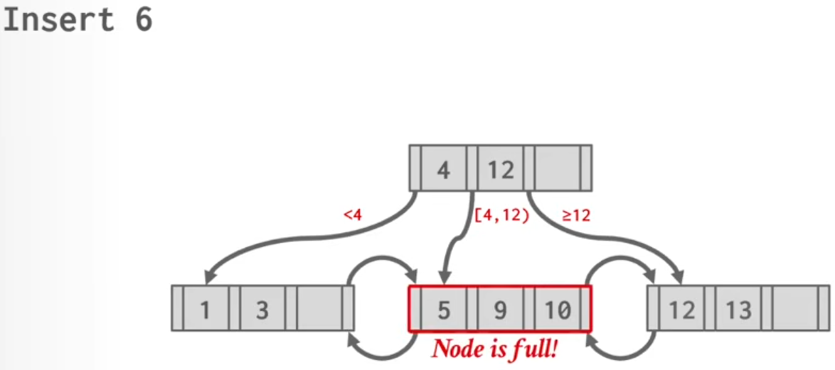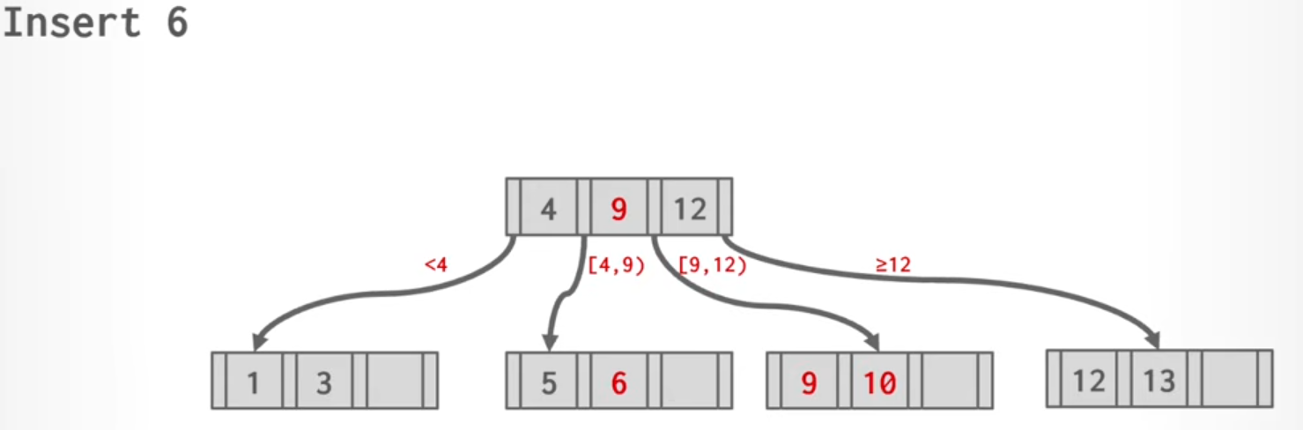
How Deletions Work
Deleting is slightly more complicated.
Step 1
Find the key and remove it from the leaf node.
Step 2
Check if the node still satisfies the half-full rule.
If yes, we're done.
Step 3: Underflow
If the node becomes less than half full, we must fix it.
There are two options.

Option 1: Stealing (Redistribution)
Borrow a key from a neighboring sibling that has extra entries.
The parent separator key is updated accordingly.
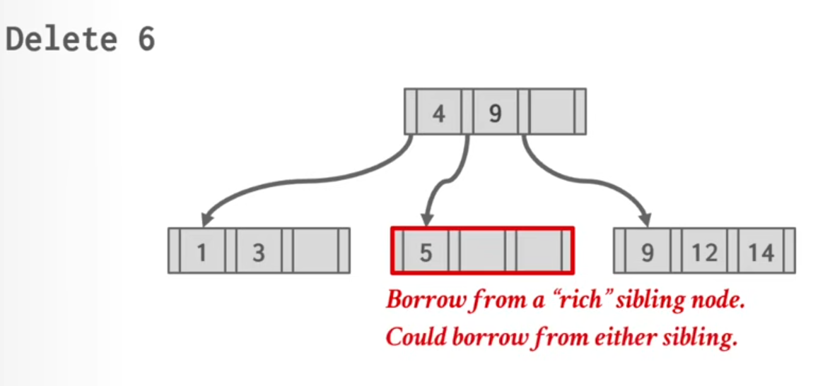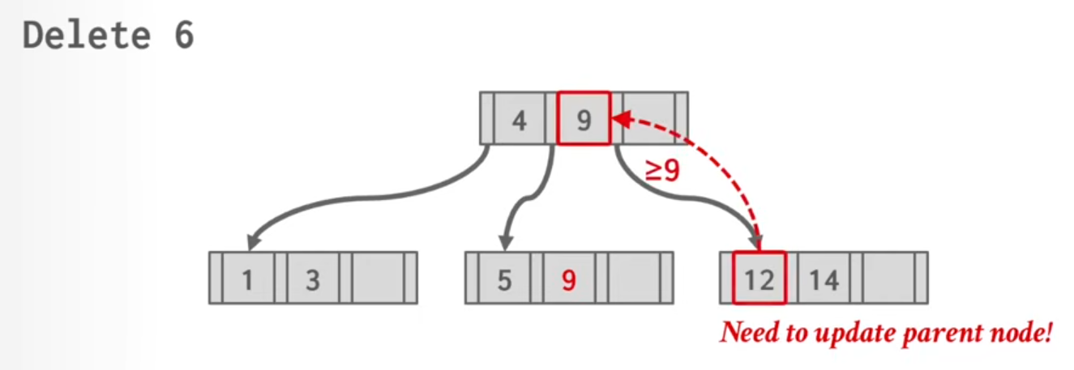
Option 2: Merging
If neighboring nodes are also nearly empty, borrowing isn't possible.
The two nodes are merged into one larger node.
The separator key in the parent is removed.
This merge can propagate upward and may even reduce the overall height of the tree.
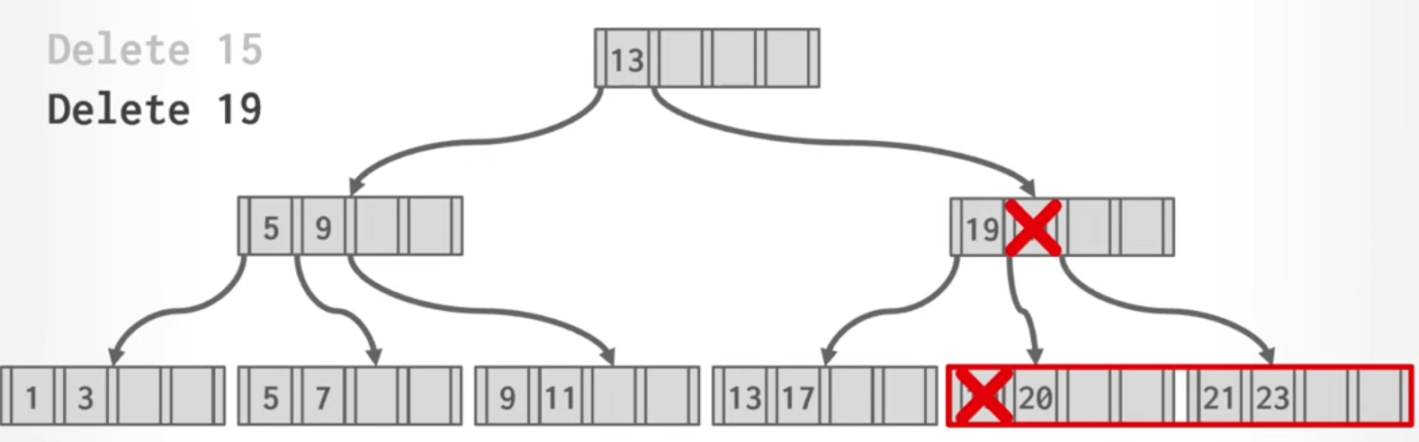
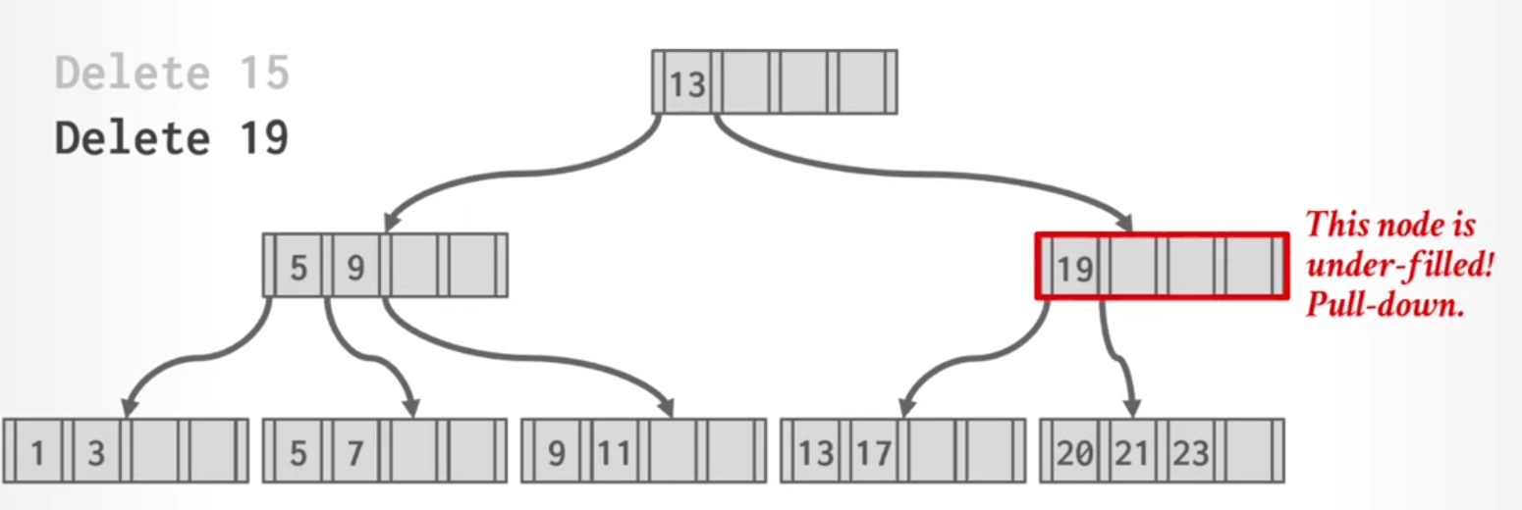
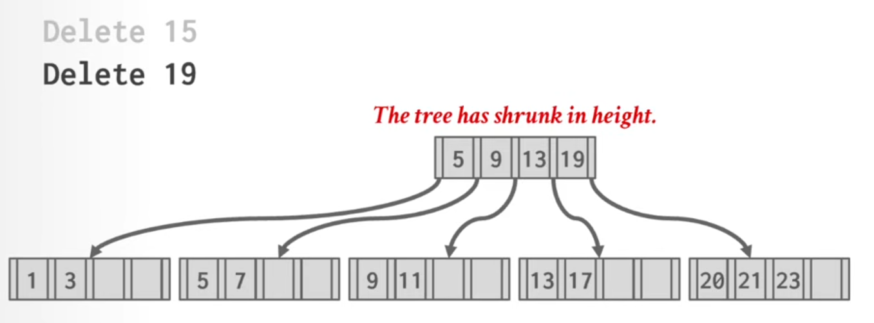

Composite Keys
Databases often create indexes on multiple columns.
Example:
(FirstName, LastName, Age)
Because keys are stored in sorted order, the database can easily search:
- FirstName only
- FirstName + LastName
- FirstName + LastName + Age
- 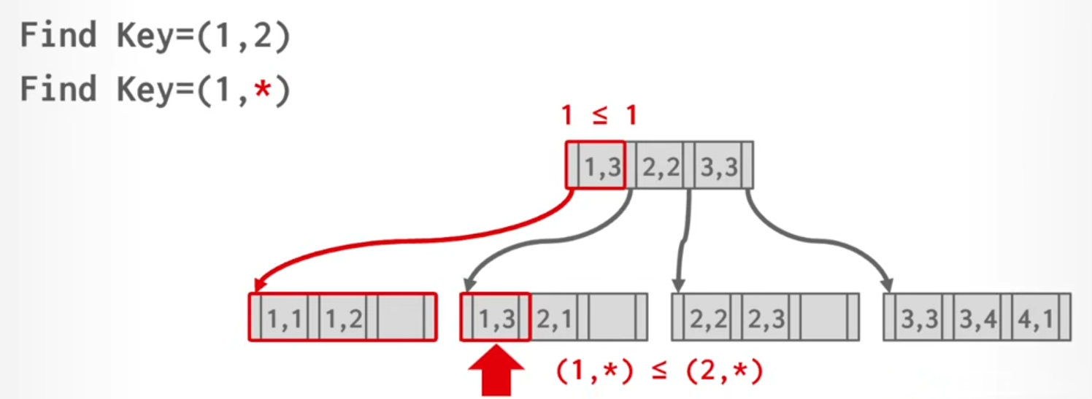

Handling Duplicate Keys
Imagine indexing ZIP codes.
Thousands of people may have:
15217
A bad solution would be:
15217 | 15217 | 15217 | 15217 | 15219
Many duplicates
This creates long linked lists and slows down lookups.
Solution
Databases make every key unique by attaching the Record ID.
Instead of:
15217
Store:
(15217, Page 4, Slot 2)
(15217, Page 8, Slot 1)
(15217, Page 9, Slot 7)
Since Record IDs are unique, every index entry becomes unique as well.
This preserves the efficiency of the B+ Tree.

Clustered Indexes
A clustered index stores table data in the same order as the index. Rows are physically stored in this order on disk.
Benefits:
- Faster range scans
- More sequential disk access
- Less random I/O
This is especially useful when reading large amounts of data.

Searching Within a Node
Once we've reached a node, we still need to find the correct key.
Common approaches include:
Linear Search
Check keys one by one.
Simple but slow for large nodes.
Binary Search
Repeatedly divide the search space in half.
Time Complexity:
O(log n)
Most common approach.
SIMD Search
Modern CPUs can compare multiple values in a single instruction.
Useful for very large nodes.
Interpolation Search
Estimates where a value should be based on the key range.
Rarely used because it only works well when keys are evenly distributed.

Advanced Optimization: Pointer Swizzling
Normally, nodes point to pages using Page IDs.
To access a page:
Page ID → Buffer Pool → Actual Memory Address
This extra lookup adds overhead.
If a page is already in memory, the database can replace the Page ID with a direct memory pointer.
This optimization is called Pointer Swizzling.
Result:
- Fewer lookups
- Faster tree traversal

Fractal Trees
In traditional B+ Trees:
- Inserts can cause splits
- Deletes can cause merges
These operations are expensive.
Fractal Trees improve write performance by adding a small buffer (called a mod log) to each node.
Instead of immediately updating lower levels:
- Changes are stored in the buffer.
- Buffers accumulate updates.
- Updates are pushed down in large batches.
Benefits:
- Much fewer disk writes
- Better performance for write-heavy workloads

